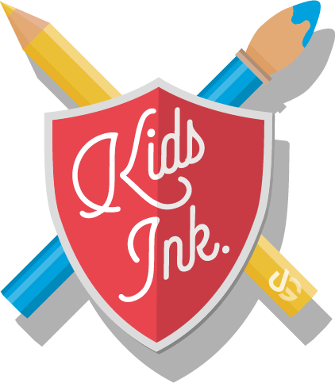

**Kids Ink Media Pack**

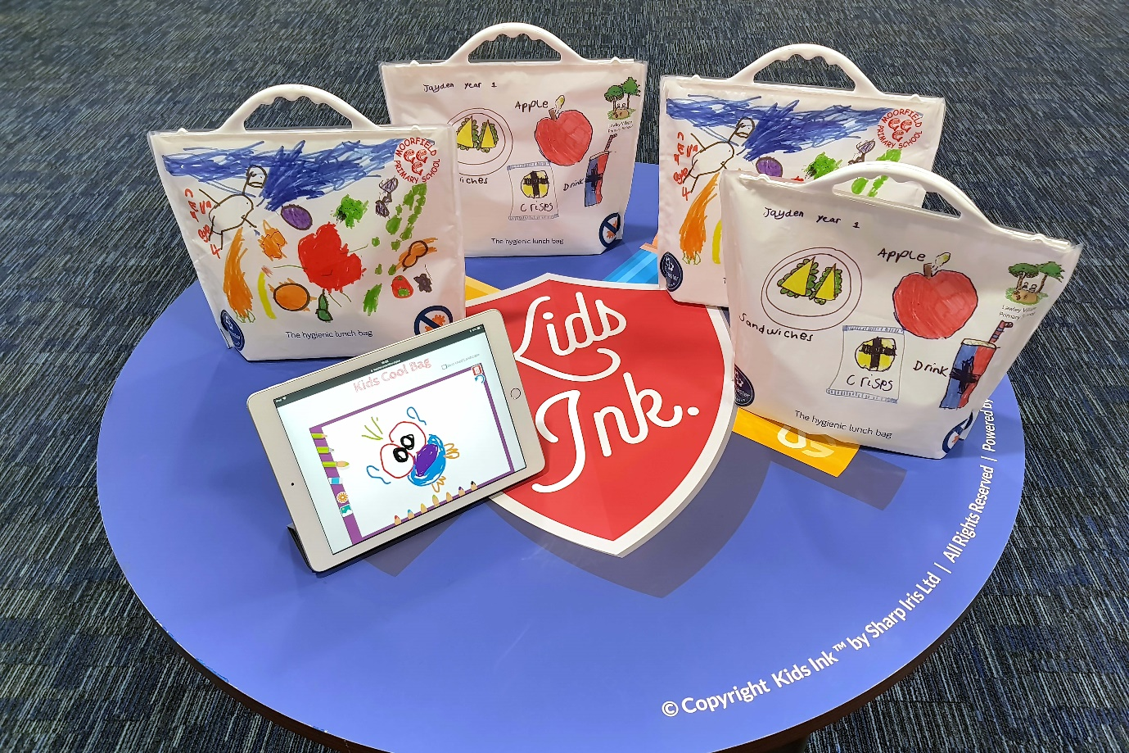

**About**

Kids Ink™ is enabling children across the country to create sustainable lunch bags. Our web to print platform and digital print capability allows kids to easily design their own personalised bag. Kids Ink™ teaches children to be environmentally friendly but in a fun, creative and interactive way. With Kids Ink™ it helps enhances children’s understanding, knowledge and retention, as it is a proven fact that kids learn best when actively engaged, therefore Kids Ink™ the perfect educational tool.

**Product Information**

Children design their bags by using the Kids Ink™ online tool drawing tool platform. Once the design has been created this then produces a print ready artwork ready for production on the digital presses. This is all controlled by using the Ultimate Digital’s Smartflow system which tracks the whole process from web, print and delivery to ensure a smooth process. All the Kids Ink™ bags are digitally printed and converted in the UK. Our close partner the Sirane Group are experts in manufacturing high quality re-usable bags, who turn the wonderful kid’s Ink™ designs into fantastic bags.

The bags are also lined with inbuilt Biomaster antimicrobial protection which inhibits the growth of harmful bacteria to grow on surfaces. This means that the lunch bags can be reused time and time again.

Kid’s Ink is an exciting partnership between Ultimate Digital, Sirane Group and Addmaster.

**Mission**

Is to educate children in being environmentally friendly but in a fun, creative and interactive way.

**Awards**

Within weeks after launching Kids Ink have been an awarded a certificate of Innovation from the Innovation of Excellence awards 2018, and have also been shortlisted at the UK Packaging awards 2018 for ‘Innovation of the year’ and ‘Flexible plastic pack of the year.

**Social media:**

**Website:** [www.kids-ink.co.uk](http://www.kids-ink.co.uk)

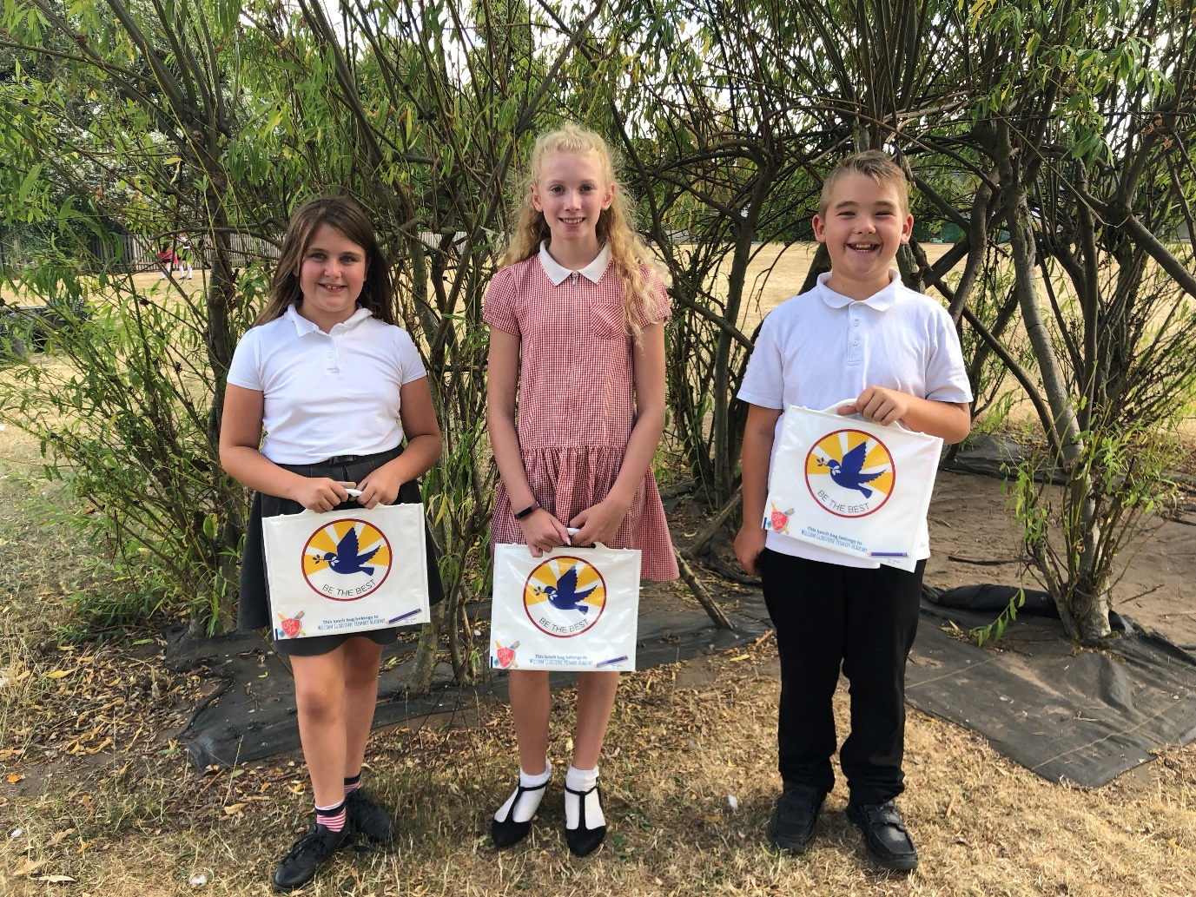**Testimonials**

“We are grateful to Kids Ink. Who asked the children to design their own personalised lunch bags. The children set about the task with gusto and alongside their designs, the company printed each pupils’ name and class too. As an added benefit, the lunch bags have a bio-master lining which is designed to kill most harmful bugs. As Design Technology is an essential part of our curriculum, giving our pupils the chance to create meaningful items with specific purposes is important.” **Haydn Mitton, Headteacher at William Gladstone Church of England Academy.**

**Children Letters**

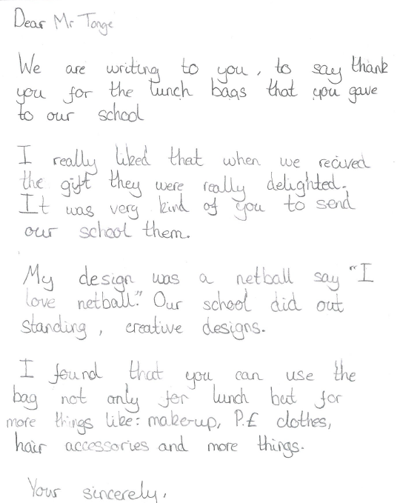

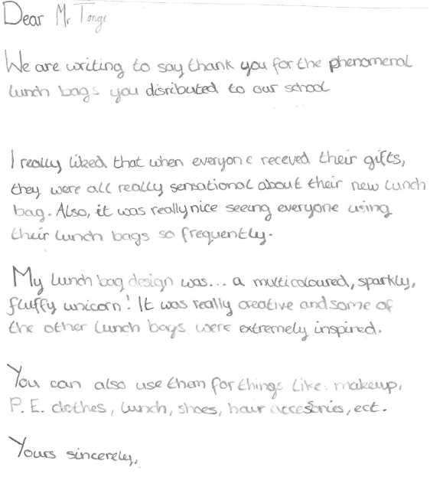

**Previous Press Releases**

**Ultimate Digital Opens the Doors to Allow School Children to Watch their Very Own Kid’s Ink Designs Print**

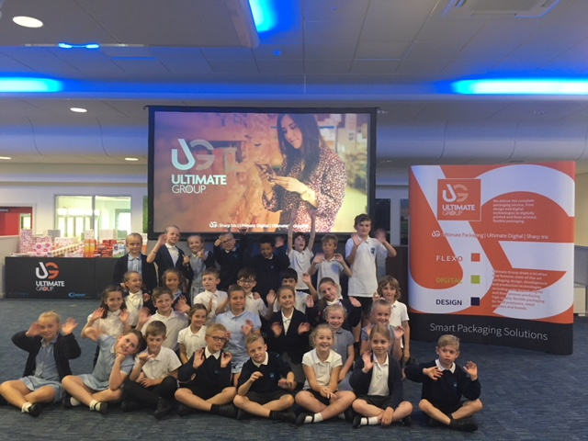

**Ultimate Digital invited Middlethorpe Primary Academy school children to participate in a fun interactive day of learning, and to watch their very own unique Kid’s Ink designs being digitally printed.**

Kids Ink is a web to print platform that allows children to design a completely unique personalised lunch bag. The purpose of Kid’s Ink is to educate children in being environmentally friendly, but in a fun, creative and interactive way.

Ultimate’s close partner B&G convert the digitally printed film and attach the handles to produce unique kid’s lunch bags. The bags are lined with Bio-master material which means that the surface of the bag is given extra protection and will reduce the ability of harmful bacteria to grow on the surface. This means that the bag is easily wipe-able and can be used time and time again.

Middlethorpe Primary Academy participated in a trial run of the new Kids Ink brand which will be fully launching this August. A class of 31 school children came bouncing through the doors with excitement to see their very own designs print. The day consisted on fun interactive workshops where the kids got to learn about the new exciting technologies that digital print can offer the market place, but most importantly learn about sustainability and packaging. The children also got to play with new interactive concepts that are not even launched on the market yet, which the children were ecstatic about. Overall the day got a big thumbs up from the children with more than positive feedback of “cool” “amazing” and “extravagant” to sum up their experience.

“The children have had a really good day, and an appreciation of how things are made from design to product. Also being able to do design and technology and promote healthy schools outside the classroom, is really valuable for learning” Michael Elliott Assistant Head at Middlethorpe Primary Academy.

These bags are a great learning tool for any school to fit into their curriculum, it has been proven that children learn best with Active engagement, getting hands on experience to enhance their understanding of a topic and retention. Kid’s Ink is one of the best ways to deliver fun and exciting lessons for all kids to enjoy. Why not start off the school year with a fun engaging project! That children get to keep and enjoy every day at lunch.

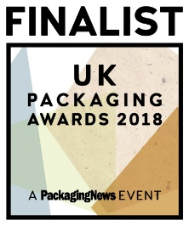**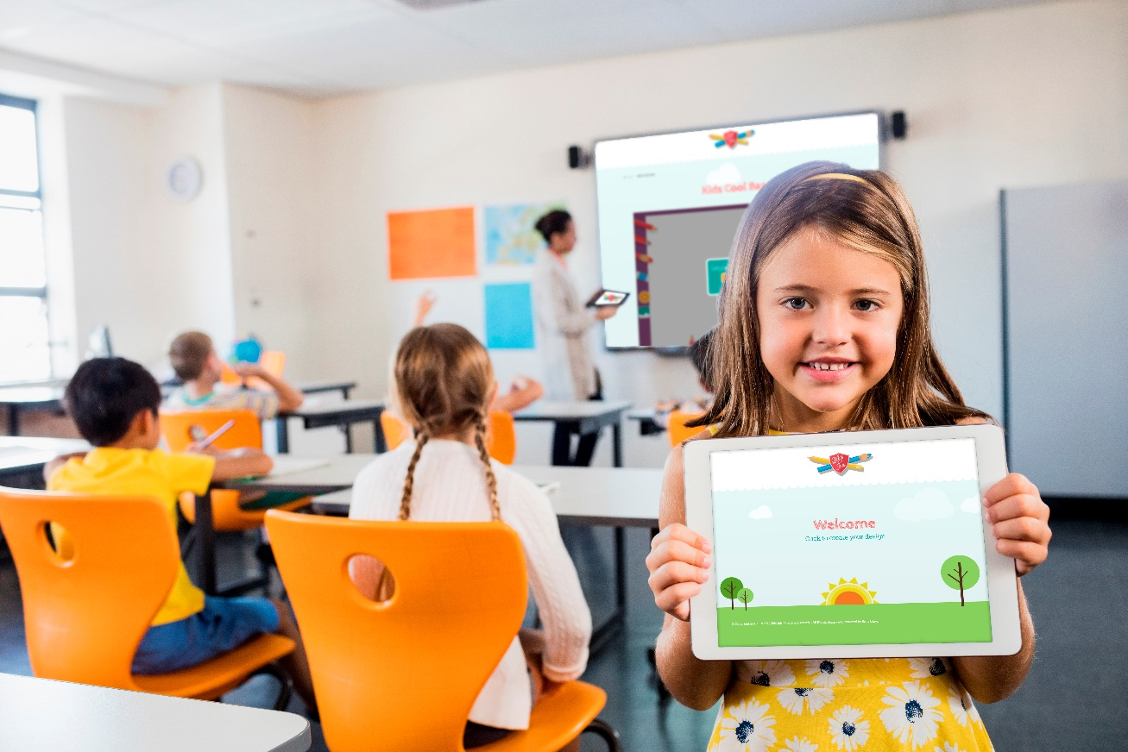Kids Ink™ shortlisted for 2 UK Packaging Awards**

**Only a few weeks after Ultimate Digital’s latest innovation Kids Ink™ was launched it has been shortlisted for ‘Innovation of the year’ and ‘Flexible plastic pack of the year’ at the 2018 UK Packaging Awards.**

Kids Ink™ is a web to print platform that allows children to design a completely unique personalised lunch bag, with the purpose to educate children in being environmentally friendly, but in a fun, creative and interactive way. This fantastic project has brought together the expertise of three UK based companies, Ultimate Digital, B&G and Addmaster, to produce these eye catching bags that kids have described as “cool” , “amazing” and “extravagant”.

Chris Tonge Executive Director of Ultimate Group said that “Kids Ink™ is unique because it is a really easy to use on line drawing tool which our Smartflow system turns into print ready digital artwork. Kids Ink™ is a world first as every other personalised campaign has used part of the design as a template but our platform enables the whole design to be totally unique to each child. The Kids Ink™ platform can also be used on every other pack formats as well, for example cartons and bottles”

Ultimate’s close partner B&G convert the digitally printed film and attach the handles to produce unique kid’s lunch bags. The bags are also lined with inbuilt Biomaster antimicrobial protection which inhibits the growth of harmful bacteria to grow on surfaces. This means that the lunch bags can be reused time and time again.

Kid’s Ink™ is expected to take the new school year by storm giving schools a tool to produce fun and interactive lessons.

**Contact Details**

**For sales enquiries please contact Emma Winton on:**

**Tel:** 07966542083

**Email:** [emma.winton@ug.uk.com](mailto:emma.winton@ug.uk.com)

**For PR enquiries please contact Laura Donington on:**

**Tel:** 01472 725521

**Email:** laura.donington@ug.uk.com



With nearly 20 years’ experience Addmaster is the market leading supplier of technically innovative additives for the plastics, textile, paper, paints and coatings industries. We help the world’s leading brand owners create a unique selling point for their products with our diverse range of high quality and pioneering additives.

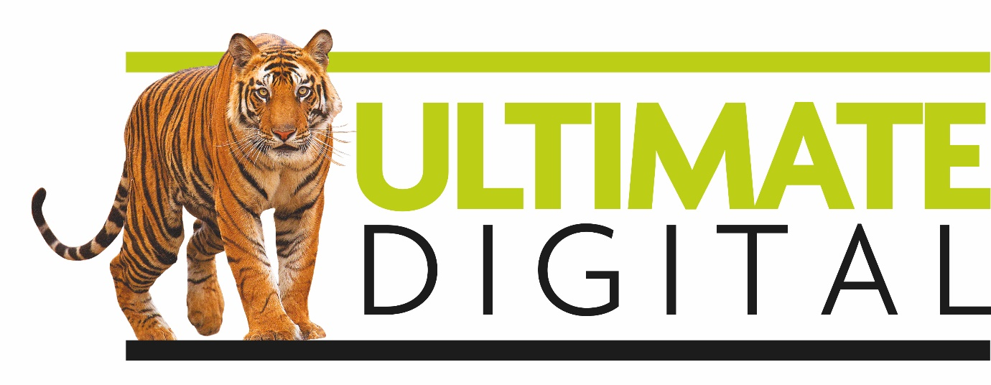

Ultimate Digital is the world pioneer and market leader in the production of digitally flexible packaging. Working closely with NPD and marketing from brands of all sizes to deliver short print runs and increasing consumer engagement through creative packaging.

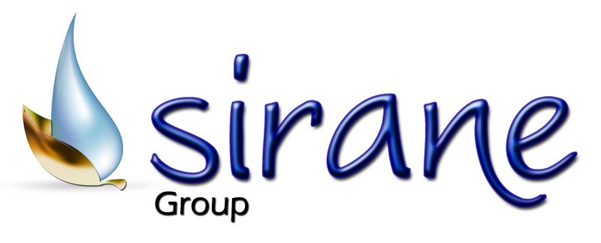

Sirane is an NPD product and process development company with full manufacturing capabilities - with four main divisions: **food packaging**; medical & healthcare; horticultural & industrial. Whereas most companies are manufacturing operations supplying a range of products, Sirane looks at your requirement and designs and develops a solution that does the job.